Cosmetic Acupuncture
2 Day Practitioner Intensive Sponsored by IICMC

As a natural alternative to botox and fillers, cosmetic acupuncture is becoming in-demand by clients all over the world. Enhance your clinical practice and offer new services to your clients, with the skills and knowledge gained in this workshop.

Learn How To Treat Common Cosmetic Complaints
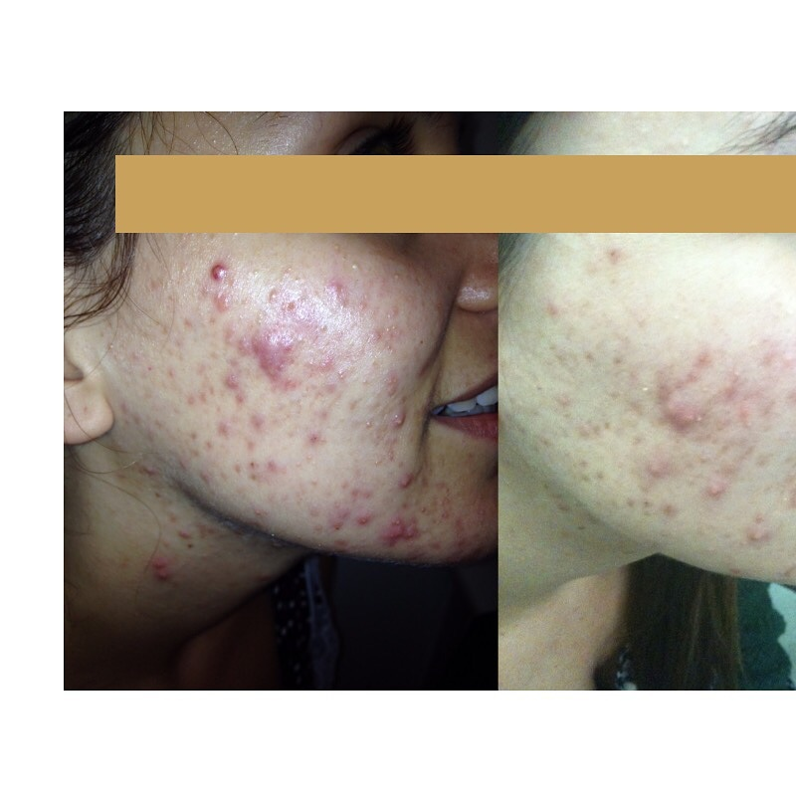
Acne & Pimples
Learn how to differentiate and treat various forms of acne and pimples, with protocols for where they present in the body.
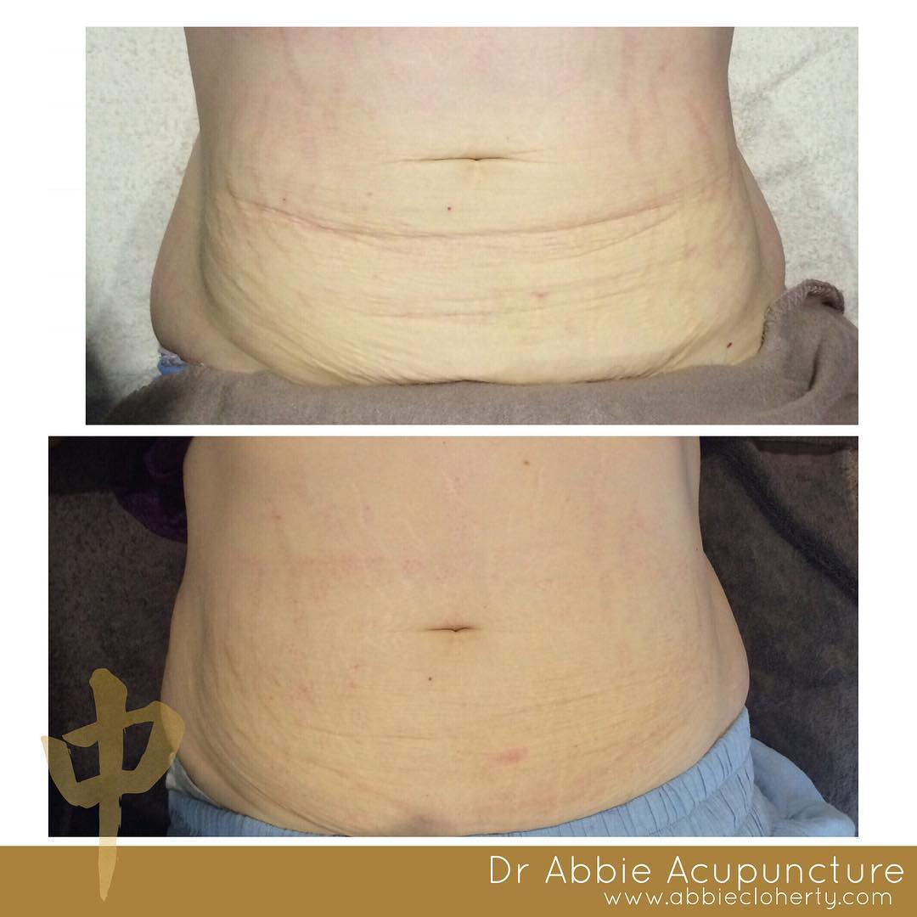
Body Treatments
Learn clinical treatments for creating a waist, c-section, “apron lift”, tighten “wedding arms” and emergency “fit into jeans”.
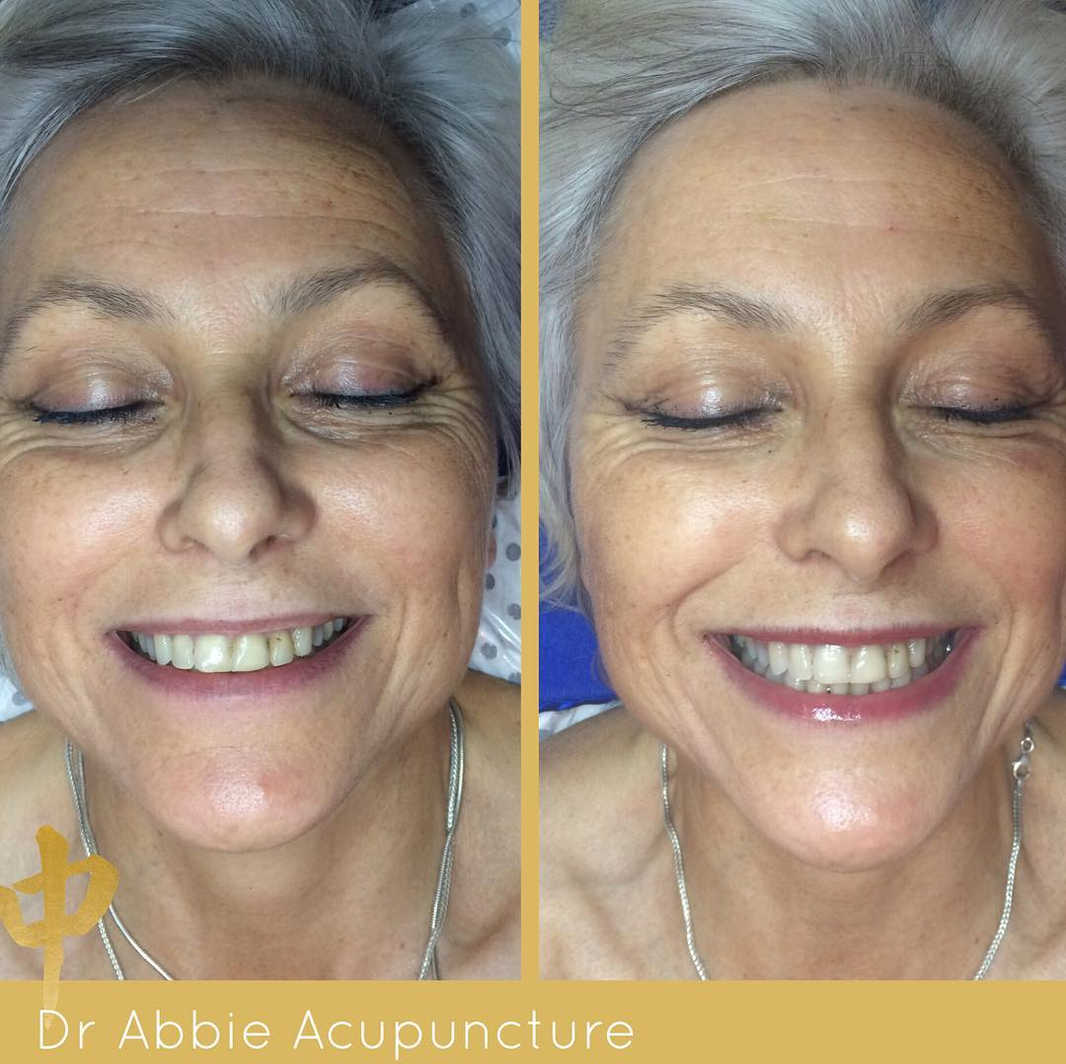
Chin Lift & Wrinkles
Learn how to treat lines and wrinkles, increase brightness + the fastest way for your clients to lose 5kg with a “chin lift”

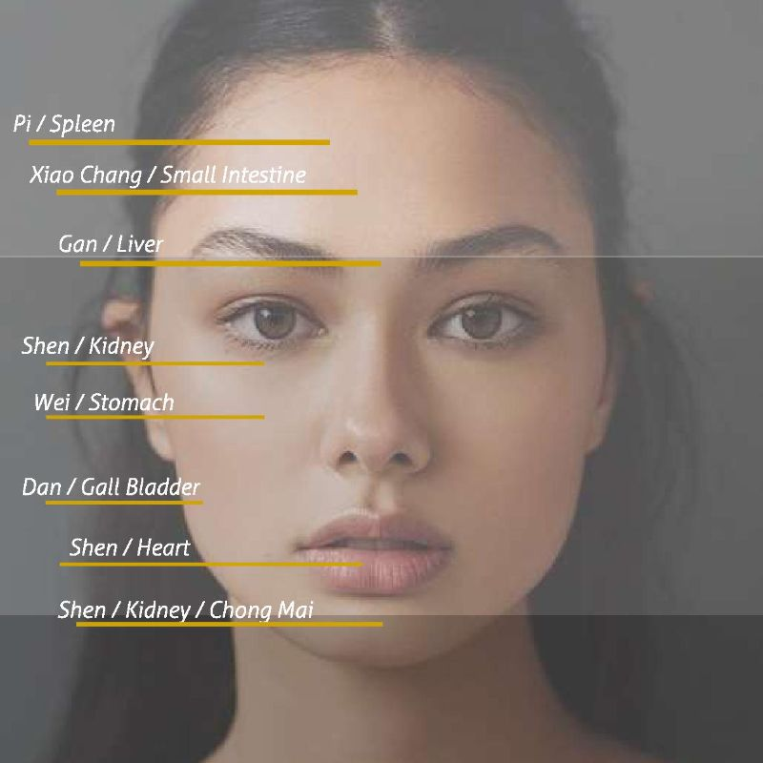
Learn Facial Diagnosis
Dr Abbie will guide you through an in depth understanding of how constitution permeates into facial expression.
You will learn how to analyse facial and physical displays, and harness organ system strengths to enhance natural beauty and appearance, and encourage Shen to shine.

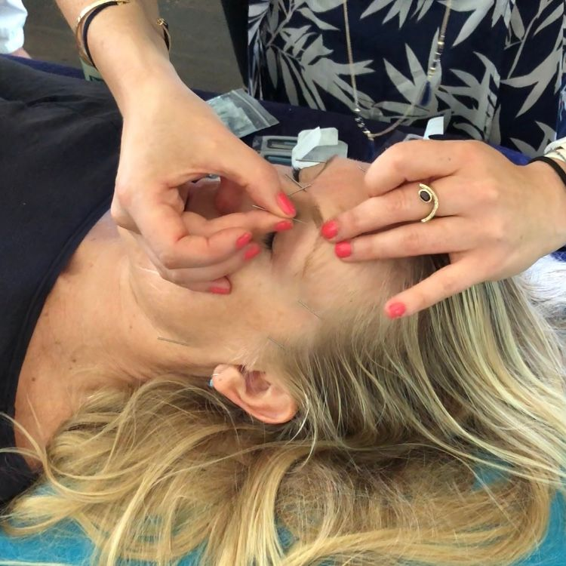
In-depth Practical Training
Deep theoretical understanding will be complemented by Dr Abbie guiding you to master the practical techniques of cosmetic acupuncture.
Experience cosmetic acupuncture as practitioner and client, learn treatment protocols for common cosmetic complaints in a safe and supportive environment.

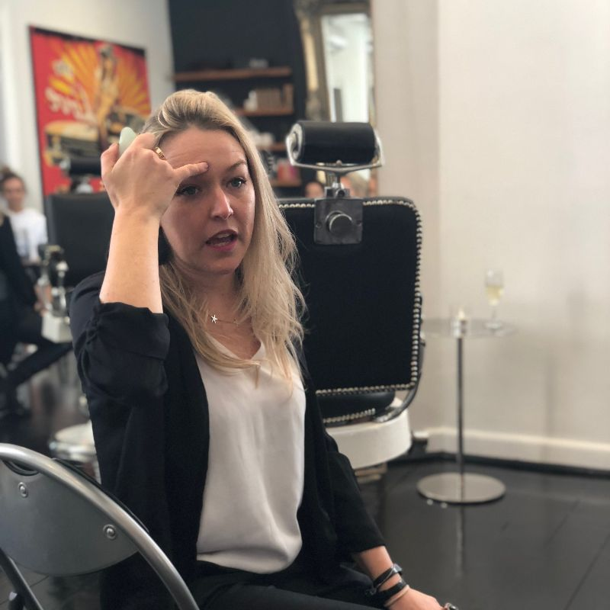
Personalised Expert Guidance
Training groups are kept small so that you receive personalised guidance from Dr Abbie throughout this immersive experience.

Facial Gua Sha
Half Day Practitioner Workshop
(NZ Acupuncture Approved for 3 CPD Points)

Join this workshop only or add it to the Cosmetic Acupuncture Practitioner Intensive to receive a special rate.
Book Now

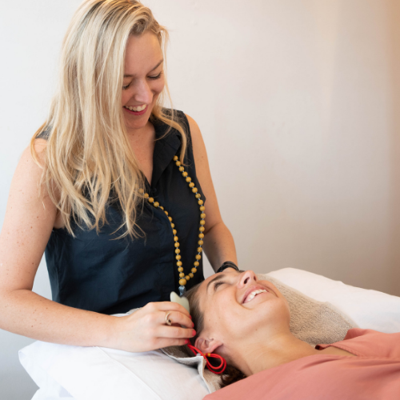
What is Gua Sha?
Gua Sha (scrapping) is a Traditional Chinese Medicine technique used to bring up blood circulation and disperse any ‘stagnation’, pain, ‘blockages’ and disruption of Qi or Xue in an area or meridian to improve health quality.

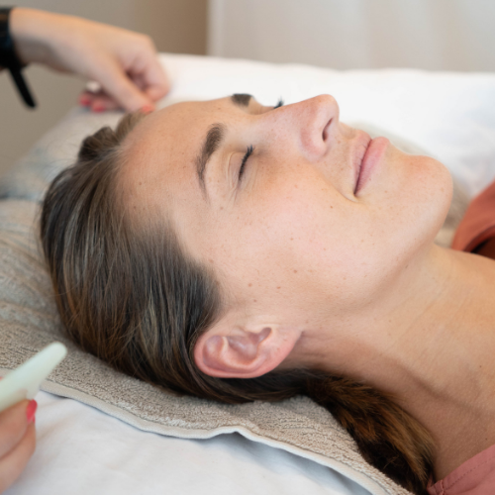
Why Facial Gua Sha?
In cosmetic uses Gua Sha enhances absorption of nutrients and skin product clears lymphatic drainage to aid skin tone, colour, brightening and pigmentation enhancement the perfect adjunct treatment to enhance any cosmetic acupuncture treatment plan.

Workshop Locations
The 2-day Cosmetic Acupuncture Intensive and the half-day Facial Gua Sha workshop are available in these locations:

Perth - September | Brisbane - September | Sydney - October
Melbourne - November | Auckland - November | Bali - October

Investment
Three options are available to you, Acupuncture NZ approved CPD hours and with payment plans available.
Cosmetic Acupuncture + Facial Gua Sha (3 days) A$880
(AcNZ Approved for 17 CPD Points)
Cosmetic Acupuncture Only (2 days) A$700
(AcNZ Approved for 14 CPD Points)
Facial Gua Sha Only (half-day) A$250
(AcNZ Approved for 3 CPD Points)

Payment plans available

bit.ly/DrAbbieCPD

What my students say:

“Abbie’s workshops are a refreshing smack in the face. In a world where women are under a ridiculous amount of pressure to look a certain way, Abbie will have you walking out of the weekend / room / course (you pick) armed with effective long lasting techniques and proven protocols and loving on yourself hard …. Splash in the face stab in the face”
— Keri Krieger

“Abbie’s cosmetic acupuncture seminar was the perfect balance of theory and practical application. After completion of the course I was confident to provide a beautiful holistic facial treatment.
Absolutely recommend this course to anyone wanting to further their skills and knowledge in cosmetic acupuncture!”
— Jess Hewitt

“My friends and I attended Abbie’s Gua Sha workshop last week and absolutely loved it. It was informative and fun and always love finding new natural techniques that work. Can’t wait to see the results! As students of Chinese medicine my friends and I learnt a lot and felt very inspired afterwards.”
— Jessica Minogue

“Abbie is an amazing lecturer!! She makes the content fun and interesting. The strong emphasis on practical techniques empowers the student to immediately commence practicing this awesome cosmetic acupuncture. Would highly recommend!”
— Andre Artmann

Secure your space today bit.ly/DrAbbieCPD

